**ICP 7**

**Team Members**

**Member 1:** Vineetha Gummadi, Class ID: 43

**Member 2:** Akhil Beerelli, Class ID: 5

**Task 1: Add Calendar Activity**

**A screenshot of a cell phone

Description generated with very high confidence A screenshot of a cell phone

Description generated with very high confidence**

**Calendar View:**

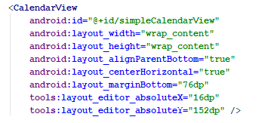

**To display the current date:**

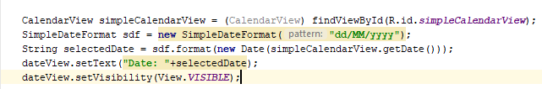

**To display the on-date change:**

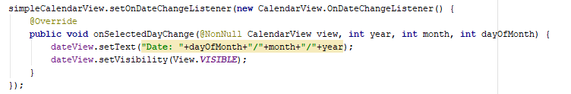

**Task 2: Generate signed APK**

